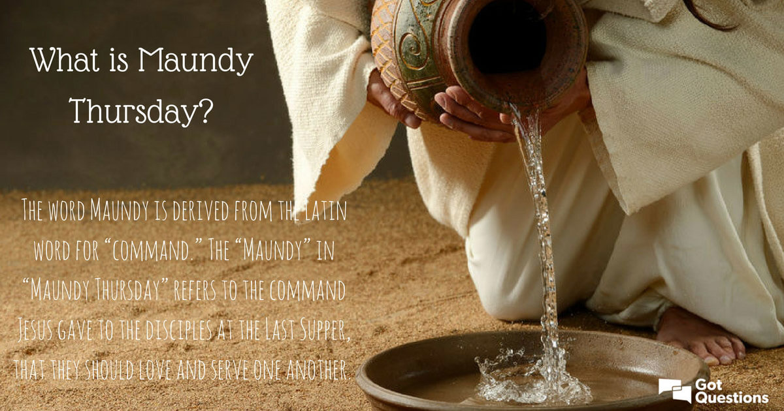

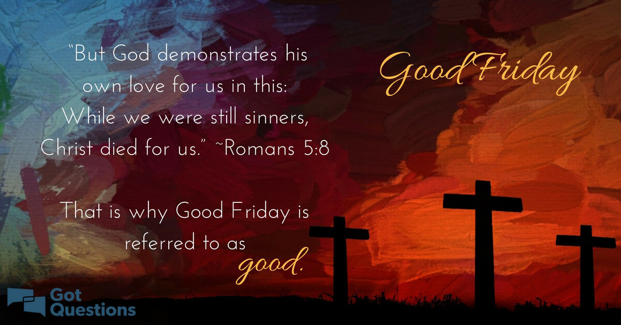

Maundy Thursday and Good Friday services will both be found on our Facebook page at 7:00 pm each day.

These will not be live stream services, but we will all watch the video service at this time and worship together in that way.

